**Exercise 1: Control Statements**

**Table Creation:**

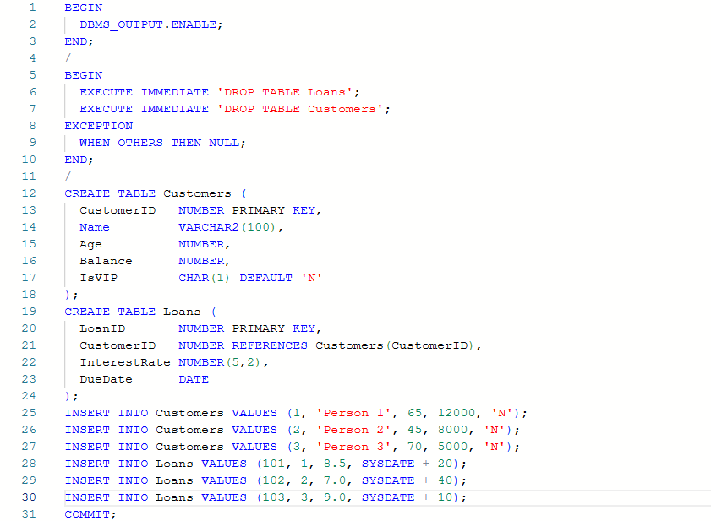

**Scenario 1:**

The bank wants to apply a discount to loan interest rates for customers above 60 years old.

**Question:**

Write a PL/SQL block that loops through all customers, checks their age, and if they are above 60, apply a 1% discount to their current loan interest rates.

**Code:**

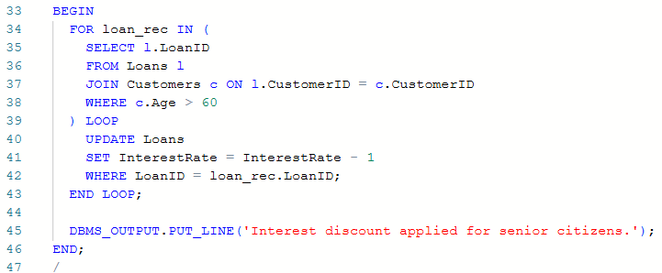



**Output:**

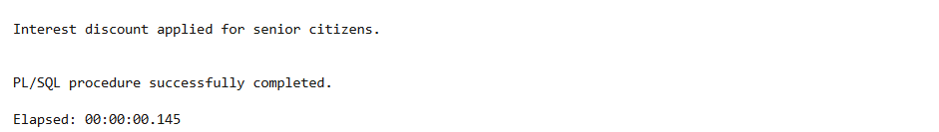

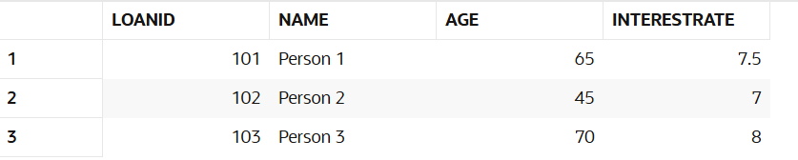

**Scenario 2:**

A customer can be promoted to VIP status based on their balance.

**Question:**

Write a PL/SQL block that iterates through all customers and sets a flag IsVIP to TRUE for those with a balance over $10,000.

**Code:**

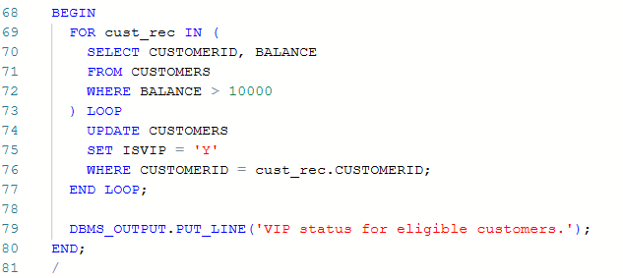

**Output:**

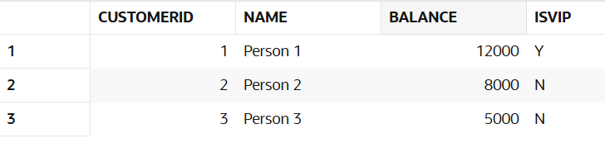

**Scenario 3:**

The bank wants to send reminders to customers whose loans are due within the next 30 days.

**Question:**

Write a PL/SQL block that fetches all loans due in the next 30 days and prints a reminder message for each customer.

**Code:**

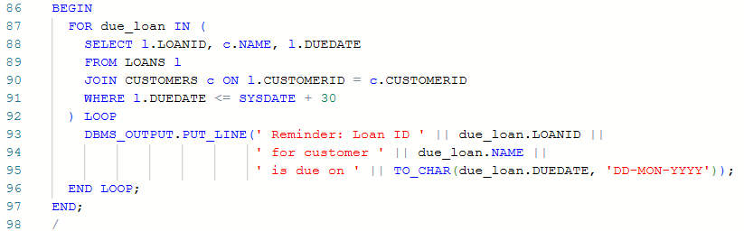

**Output:  
